**ARTICLE REVIEW**

**TOPIC :- EULER’S METHOD**

**Student Details :-**

* Name :- Ankit Senjaliya
* Enrollment No. :- 19BT04046
* Branch :- Computer Science And Engineering
* Semester :- 4

**Faculty Mentor Details :-**

* Mr. Atul Kotle

**INTRODUCTION**

In this chapter, we will consider a numerical method for a basic initial value problem, that is, for

Y’ = F (x, y), y (0) = α. (1.1)

We will use a simplistic numerical method called Euler’s method. Because of the simplicity of both the problem and the method, the related theory is relatively transparent and will be provided in detail. Though we will not do so, the theory developed in this chapter does extend to the more advanced methods to be introduced later, but only with increased complexity. With respect to (1.1), we assume that a unique solution exists, but that analytical attempts to construct it have failed.

Another technique, which we will verify in this article, uses methods of approximations the solution of original problem. This is the technique that is generally taken as the approximation methods give more perfect results and relative error information.

Euler modified method and Runge Kutta method are performed without any discretization, alteration or limiting assumption for solving initial value problems of ordinary differential equations. The Euler method is conventionally the first numerical method. It is extraordinarily easy to realize and geometrically simple to

expressive however not very handy, the technique has restricted accuracy for further intricate functions. A more vigorous and complicated numerical method is the Runge Kutta method.

This method is the most commonly used one since it provides consistent initial values and is especially suitable when the calculation of higher derivatives are intricate.

Numerical methods are usually used for solving mathematical problems that are articulated in the field of science and engineering in which case the determination of the exact solution is so hard or impossible. Only a few numbers of differential equations can be solved analytically.

**ABSTRACT**

Euler’s method is the most basic and simplest explicit method to solve first-order ordinary differential equations (ODEs). Many other complex methods like the Runge-Kutta method, Predictor-Corrector methods, etc. have been developed on the basis of this method. In this paper, the basic concept of Euler's method with some of its established modified rules such as the Modified Euler’s method and the Mid- Point method have been discussed. The main focus is confined to the geometrical interpretation of these methods and to find a way to reduce the errors. Finally, a modification has applied to these methods to improve the performance by reducing errors and naming the new method as Enhanced Euler’s method. Numerical experiments and graphical results have been discussed in the paper. MATLAB programs have been used for numerical and graphical computation.

## BACKGROUND

## The idea of tracing a path on a chart when you know the direction of travel (but not a position function) is very old. Ancient mariners estimated the position of their ships by keeping track of the directions in which they sailed day-by-day. This process is called dead reckoning, because a navigator deduced where a ship was by using careful notes on its headings and the elapsed time. The mariners did know, of course, the point from which the ship started. In much the same way Leonhard Euler (1707-1783) developed a method that uses the starting point of a function and its direction (i.e., derivative) to approximate the graph of the function

#### **Summary**

In order to use Euler's Method to generate a numerical solution to an initial value problem of the form:

y’ = f(x, y)

y ($x_{0}$) = $y_{0}$

we decide upon what interval, starting at the initial condition, we desire to find the solution. We chop this interval into small subdivisions of length *h*. Then, using the initial condition as our starting point, we generate the rest of the solution by using the iterative formulas:

xn+1 = xn + h

yn+1 = yn + h f(xn, yn)

to find the coordinates of the points in our numerical solution. We terminate this process when we have reached the right end of the desired interval.

**PURPOSE**

In this lab we will learn how to draw the graph of a function and how to approximate values of a function when we know only its rate of change and a starting point for the graph.

**PREVIEW**

From the information that f’(t) = $2^{\frac{{-t}^{2}}{2}}$ and f(−5) = 0 the following approximate graph of f can be produced, even though we do not have a formula for the function f.

**EULER’S METHOD**

Iterating the approximation y (a + ∆t) ≈ y(a) + f(y(a), a) ∆t, we can numerically approximate solutions to initial value problems y’ = f (y, t) and y ($t_{0}$) = $y_{0}$.

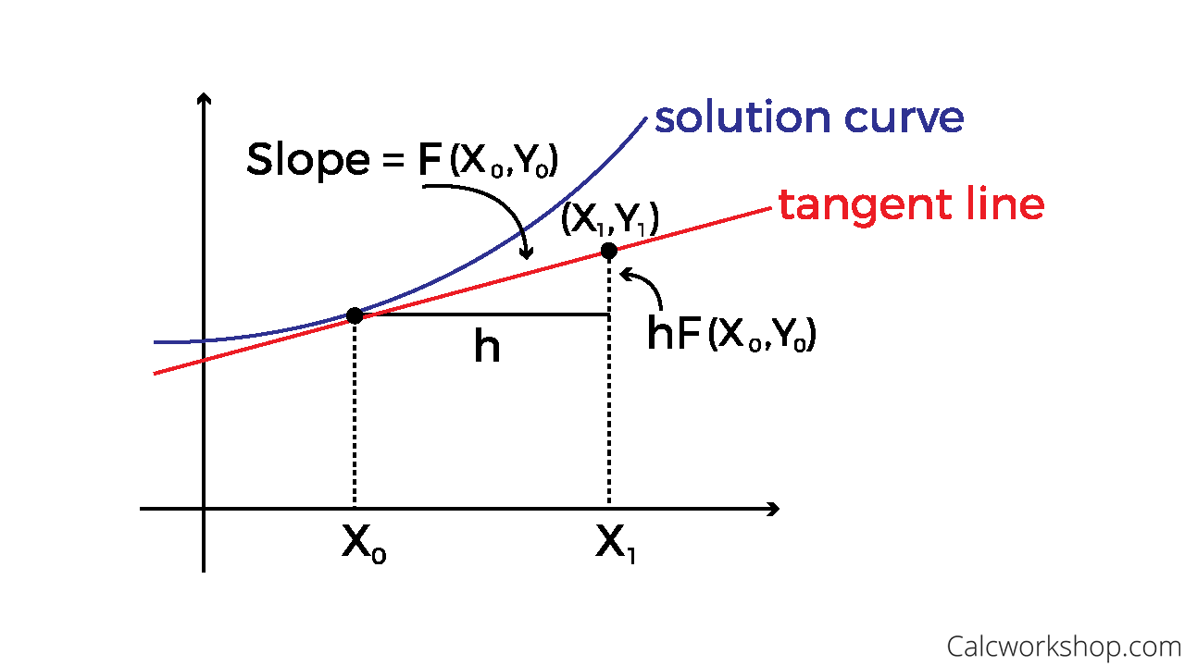

That is, given that y satisfies the above initial value problem, to approximate y(a), fix a positive integer n, set ∆ = $\frac{a - t_{0}}{n}$, and define

$t_{i}$: = $t_{0}$ + i∆ (for 0 ≤ i ≤ n).

We know that y ($t_{0}$) = $y_{0}$. Approximating, we have

y ($t_{1}$) = y ( $t_{0}$ + ∆)

≈ y ($t_{0}$) + ∆y’ ($t_{0}$)

= $y_{0}$ + ∆ f ($y_{0}$, $t_{0}$)

=: $y_{1}$

Repeating this process, we find that,

y ($t_{2}$) ≈ y1 + ∆f ($y_{1}$, $t_{1}$) =: $y_{2}$, . . . , y(a) = y($t_{n}$) ≈ $y_{n - 1}$ + ∆f($y_{n - 1}$, $t_{n - 1}$).

Example :- Apply Euler’s Method to solve y’ = x + y. Given

y(0) = 0. Find y at x = 0.8 using step length 0.2.

Answer :-

Given,

y’ = x + y, $x_{0}$ = 0, $y_{0}$ = 0, $x_{n}$ = 0.8, h = 0.2

Then, using Euler’s Method

$y_{n + 1}$ = $y_{n}$ + hf($x_{n}$, $y_{n}$) ……. (1)

Putting n=0, for finding first approximation than we have,

$y_{1}$ = $y_{0}$ + hf($x_{0}$, $y_{0}$)

$y_{1}$ = 0 + 0.2 * 0

$y_{1}$ = 0

$x_{1}$ = $x_{0}$ + h

$x_{1}$ = 0 + 0.2

$x_{1}$ = 0.2

Putting n=1, for finding second approximation than we have,

$y_{2}$ = $y_{1}$ + hf($x_{1}$, $y_{1}$)

$y_{2}$ = 0 + 0.2 * 0.2

$y_{2}$ = 0.04

$x_{2}$ = $x_{1}$ + h

$x_{2}$ = 0.2 + 0.2

$x_{2}$ = 0.4

Putting n=2, for finding second approximation than we have,

$y_{3}$ = $y_{2}$ + hf($x_{2}$, $y_{2}$)

$y_{3}$ = 0.04 + 0.2 * 0.44

$y_{3}$ = 0.128

$x_{3}$ = $x_{2}$ + h

$x_{3}$ = 0.4 + 0.2

$x_{3}$ = 0.6

Putting n=3, for finding second approximation than we have,

$y_{4}$ = $y_{3}$ + hf($x_{3}$, $y_{3}$)

$y_{4}$ = 0.128 + 0.2 * 0.728

$y_{4}$ = 0.2736

$x_{4}$ = $x_{3}$ + h

$x_{4}$ = 0.6 + 0.2

$x_{4}$ = 0.8

At y(0.8) = 0.2736

**CONCLUSION**

This latter conclusion makes intuitive sense because Euler's method uses straight-line segments to approximate the solution. Hence, Euler's method is referred to as a first-order method. After this exploration of Euler’s method, we have learned several things about when it should be used and when other numerical methods would be more appropriate. In particular, Euler’s method is not the best choice when |y’| takes on large values near the initial data, nor when a computationally efficient method is required.

Although we can improve the method slightly, by considering more than the immediately previous point, this improvement is limited. Generally, the approximation gets less accurate the further you are away from the initial value in many cases, then, Euler’s method is not the most appropriate numerical method.

Better accuracy is achieved when the points in the approximation are closer together. Your approximation is going to be above the actual curve if the function is concave down and below the actual curve if the function is concave up. The error can be reduced by decreasing the step size. The method will provide error-free predictions if the solution of the differential equation is linear, because for a straight line the second derivative would be zero.

**REFERENCES**

[1] Ogunrinde, R.B., Fadugba, S.E. and Okunlola, J.T. (2012) On Some Numerical Methods for Solving Initial Value Problems in Ordinary Differential Equations. IOSR Journal of Mathematics, 1, 25-31.

[2] Akanbi, M.A. (2010) Propagation of Errors in Euler Method, Scholars Research Library. Archives of Applied Science Research, 2, 457-469.

[3] Euler H., Institutiones calculi integralis, Volumen Primum (1768), Opera Omnia, Vol. XI, B. G. Teubneri Lipsiae et Berolini, MCMXIII, 1768.

[4] Butcher J. C., General linear methods: A survey, Appl. Numer. Math., 1985, 1. 107 – 108.